Software Design Document
Prepared by:
Veronia Sameh Shenouda 2023/00592
Nourhan Khaled 2023/04880
Mohamed Hesham 2023/00428
Mohanad Ezzat 2023/08326
Jana Tamer 2023/05507
- Introduction
This document provides an overview of the AI-powered language learning platform and explains how the system is designed to meet its functional requirements. It serves as a guide for understanding the system architecture and component interactions.
  - Purpose
This Software Design Description (SDD) defines the overall architecture and detailed system design of the AI-powered language learning platform. The platform utilizes artificial intelligence and conversational chatbots to support personalized and interactive language acquisition.
This SDD serves as a reference for developers, system architects, and the project manager throughout the software development lifecycle. It translates the previously submitted Software Requirements Specification (SRS) into concrete technical designs by detailing how each functional requirement and use case is implemented. The document presents these designs through structured explanations and system diagrams, which are included to clearly illustrate system behavior, component interactions, and data flow.
1.2 Scope
This Software Design Description (SDD) describes the design of an AI-based language learning website that uses chatbots to support interactive language practice. The system allows users to learn and practice a new language through conversational exercises, personalized content, quizzes, and progress tracking.
The document focuses on the system architecture, main components, and their interactions. Details related to system deployment, maintenance, and instructional methodology are outside the scope of this document.
1.3 Intended Audience
This document is intended for software developers, system designers, project managers, and academic evaluators involved in the development and assessment of the AI-based language learning website. It provides the technical details required to understand the system design and implementation.
Software Developers
- To understand the system architecture and component interactions.
- To use the design details as guidance during implementation.

System Designers / Architects
- To ensure the system design meets the functional requirements defined in the SRS.
- To maintain consistency and scalability across system components.
Project Manager
- To track development progress against the defined system design.
- To support planning, task allocation, and risk management.
Academic Evaluators / Instructors
- To assess the correctness, completeness, and quality of the system design.
- To verify alignment between requirements, design, and implementation.

1.4 Definitions and Acronyms
Definitions
- Software Design Description (SDD):
A document that describes the system architecture, components, and design details of the AI-based language learning platform. It explains how the system requirements are implemented.
- Software Requirements Specification (SRS):
A document that defines the functional and non-functional requirements of the system, serving as the basis for system design.
- Artificial Intelligence (AI):
The ability of the system to perform tasks such as language understanding, response generation, and personalized learning support.
- Chatbot:
A conversational software component that interacts with users to provide language practice and feedback.
- User:
An individual who uses the platform to learn or practice a language.

Acronyms
- SDD – Software Design Description
- SRS – Software Requirements Specification
- AI – Artificial Intelligence
- UI – User Interface
- UX – User Experience

- System Overview
The system is an AI-powered language learning website designed for users who want to learn a new language. It offers interactive chatbot conversations and structured lesson levels for each language, covering a wide range of topics to support practical language use.
The platform provides personalized learning by adapting lessons and exercises to the user’s progress and skill level. Users can also take quizzes to test their understanding, with instant feedback to help reinforce learning. All features are powered by AI, ensuring a tailored and engaging learning experience.
- Design Viewpoints
This section presents system design from multiple perspectives to provide a comprehensive understanding of the architecture, component interactions, and system behavior. Each viewpoint focuses on a particular aspect of the system, aiding developers, designers, and evaluators in visualizing and verifying the design.

  - Context Diagram
A context diagram is a high-level system diagram that represents the system as a single unit and shows its interaction with external actors and external systems, clearly defining the system boundary and the data exchanged.
Description for This System:
This context diagram presents the Language Learning Chatbot Platform as a single system and shows its interactions with external actors and services. Students and administrators access the system through a web browser, while the platform communicates with a database, local content files, Google OAuth for authentication, and the OpenAI API for quiz generation. The diagram defines the system boundary and the main data exchanges at a high level.
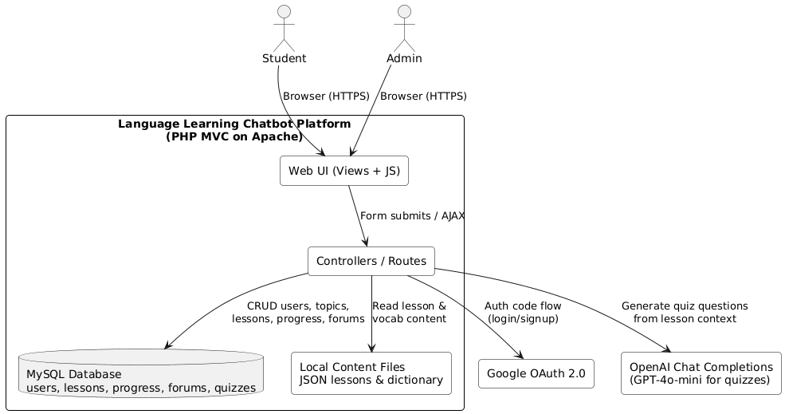

  - Use Case Diagram
A use case diagram is a UML diagram that illustrates the functional requirements of a system by showing how external actors interact with the system through use cases.

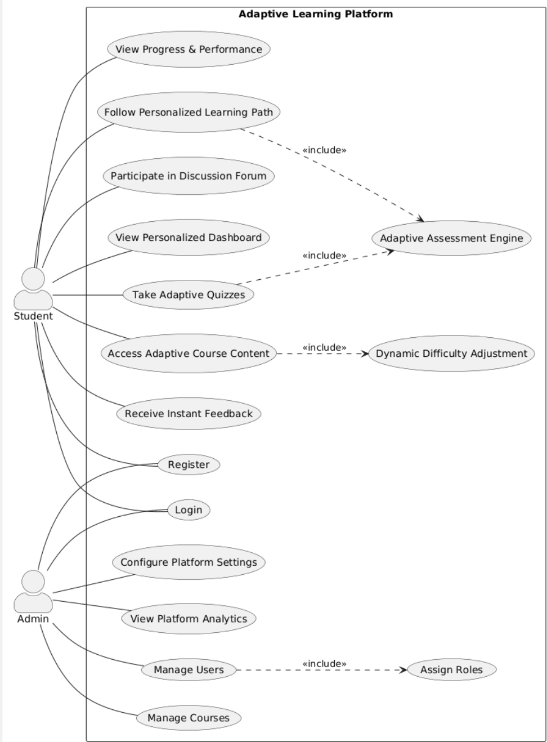

  - Sequence Diagrams:
A sequence diagram is diagram that shows how multiple system components interact over time, illustrating the order of messages exchanged to complete a specific use case.
Admin Sequence:
This diagram shows how an admin logs in, manages users, and views analytics through interactions between the UI, backend services, and the database.
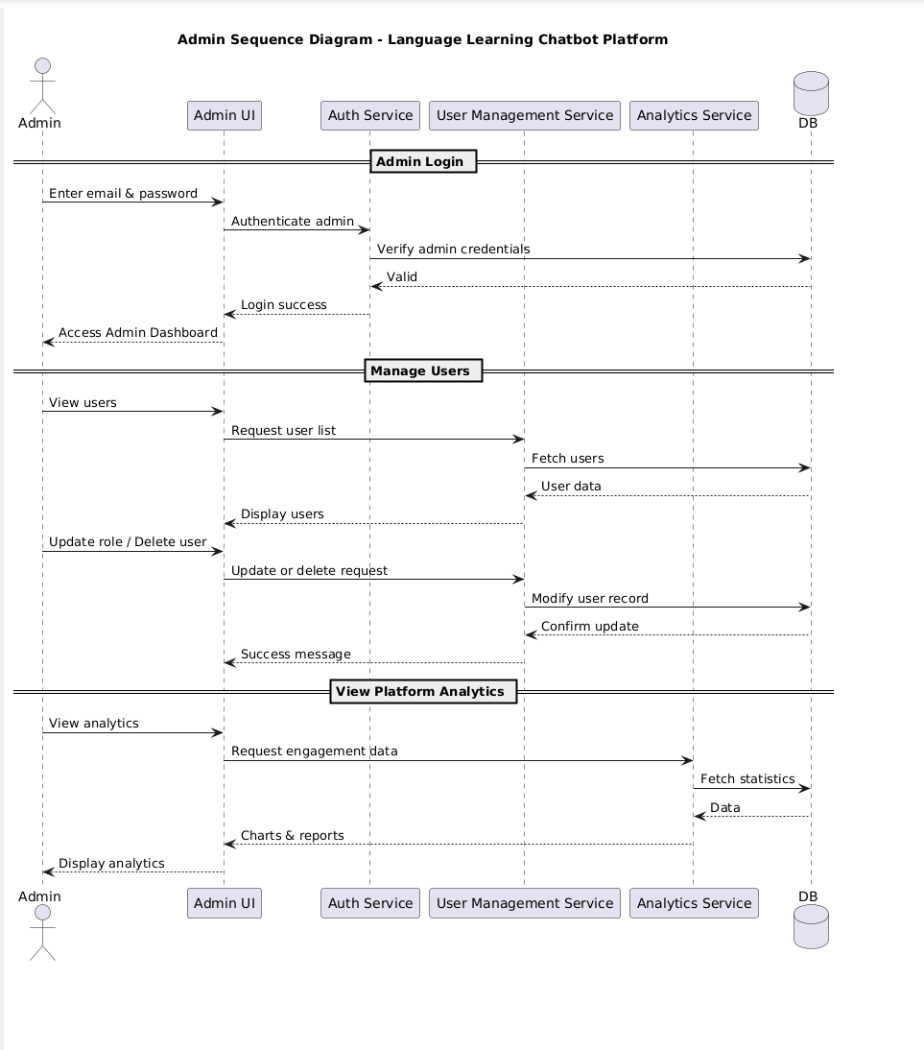
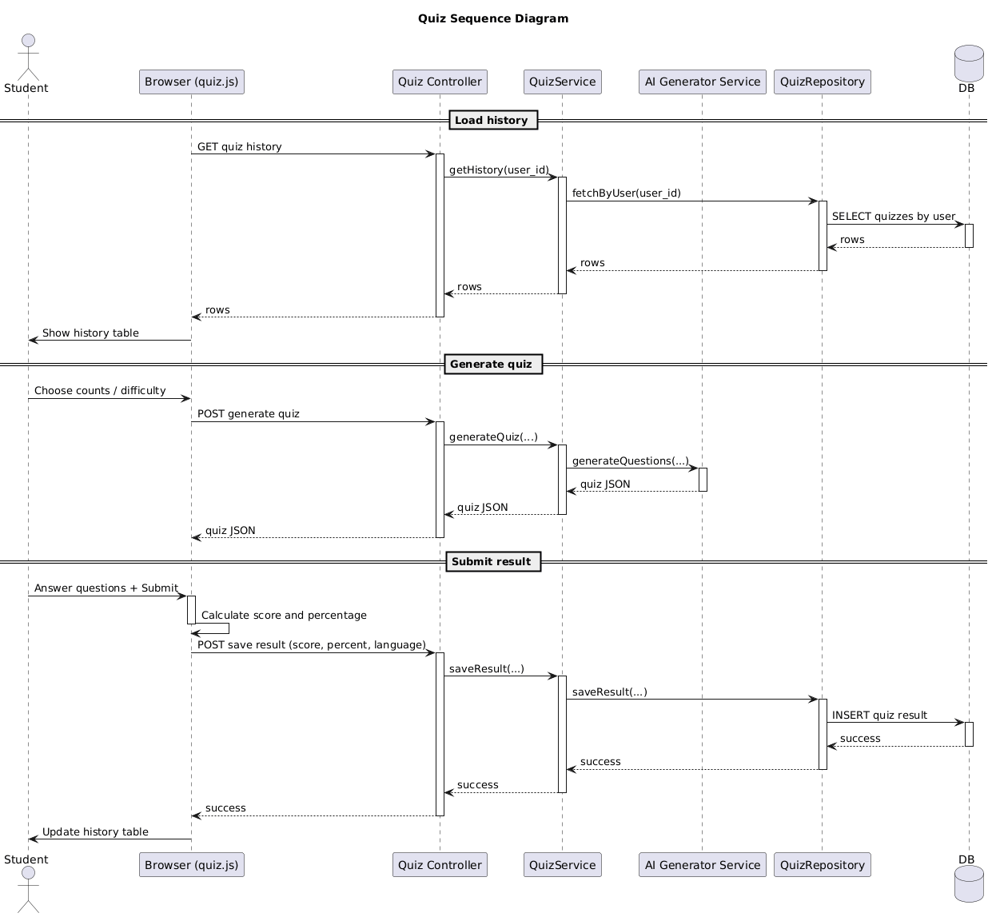
Quiz Flow
Sequence diagrams for the quiz feature illustrate the step-by-step interactions between the user, the system, and backend components during a quiz session. They clarify how questions are delivered, responses are processed, and instant feedback is provided to support learning.

  - Class Diagram
The class diagram of the Language Learning Chatbot presents a well-structured, layered object-oriented design that clearly separates responsibilities across the system. It models the core domain entities such as User, Language, Topic, Lesson, Quiz, Document, and VocabularyItem, which represent the main learning, assessment, and content-management features of the platform. Interfaces are used to enforce abstraction and flexibility, particularly for authentication, data repositories, and AI-based quiz generation, allowing the system to be easily extended or modified without affecting higher-level components. Service classes handle specialized logic such as analytics, activity logging, AI grammar analysis, badge evaluation, and external AI integration, while controllers act as intermediaries between user requests and the underlying business logic. Relationships such as composition, aggregation, inheritance, and dependency are used appropriately to express ownership, reuse, and interaction between components. Overall, the diagram reflects a scalable, maintainable architecture that follows good software engineering practices, making the system easy to understand, extend, and manage.

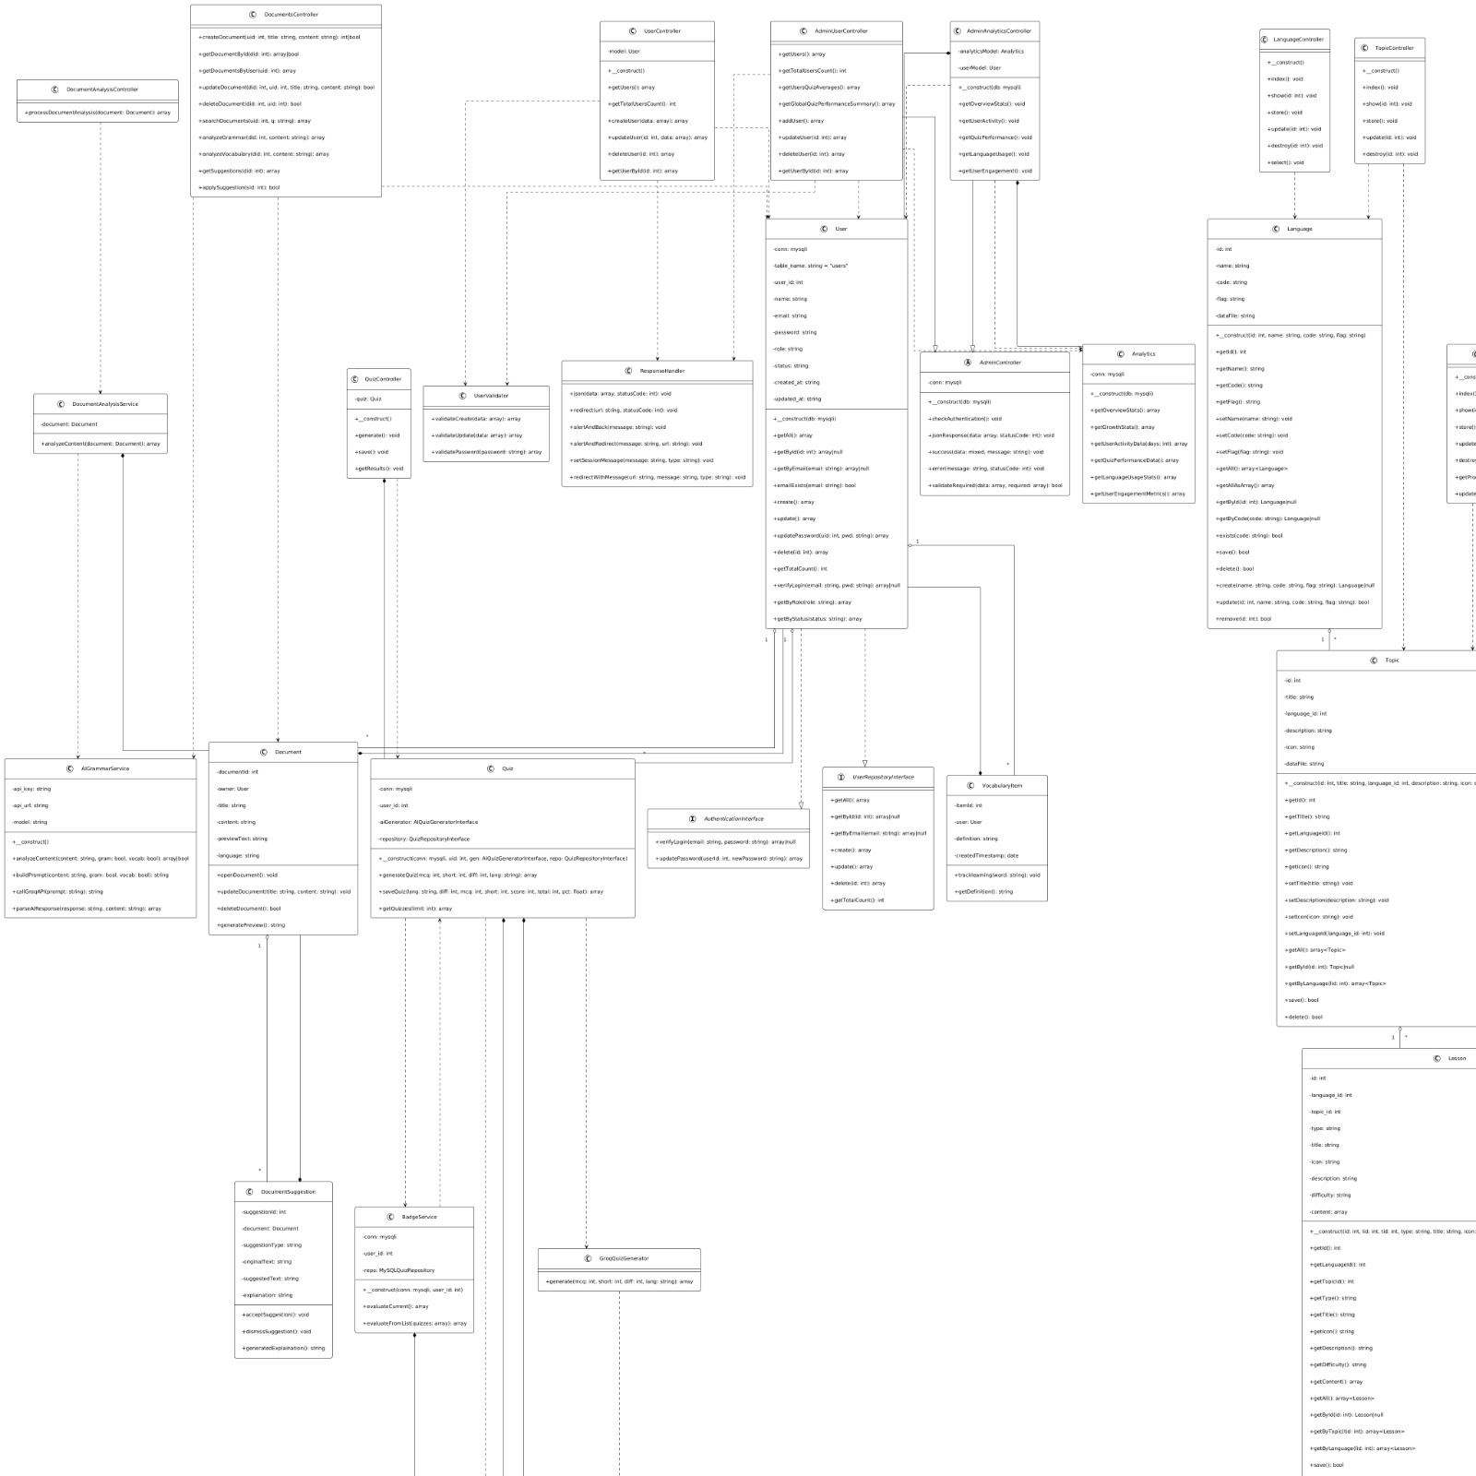

  - Activity Diagram
An activity diagram is a UML diagram that represents the flow of actions and decisions in a system, showing how activities are performed from start to finish.
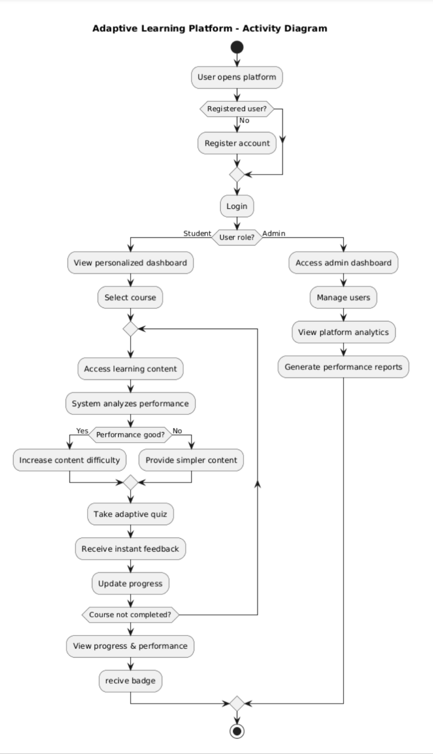
This activity diagram shows the flow of actions in the adaptive learning platform, from user login to role-based activities for students and administrators. It highlights how learning content adapts based on student performance and how progress and analytics are handled.

  - State Diagram
A state diagram is a UML behavioral diagram that represents the lifecycle of an object, showing its possible states and the events that trigger transitions between those states over time.
Quiz Lifecycle:
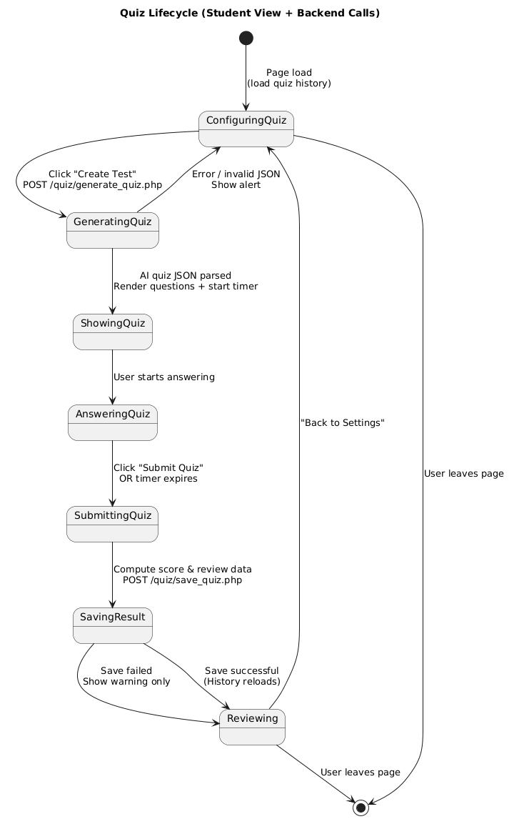
This state diagram models the lifecycle of a quiz session from the student’s perspective, including key backend interactions. It illustrates how the quiz object transitions from configuration and generation to answering, submission, result saving, and review. Each transition is triggered by user actions (such as creating or submitting a quiz) or system events (such as timer expiration or backend responses), clearly defining the valid flow of states throughout a quiz session.
Lesson Lifecycle:
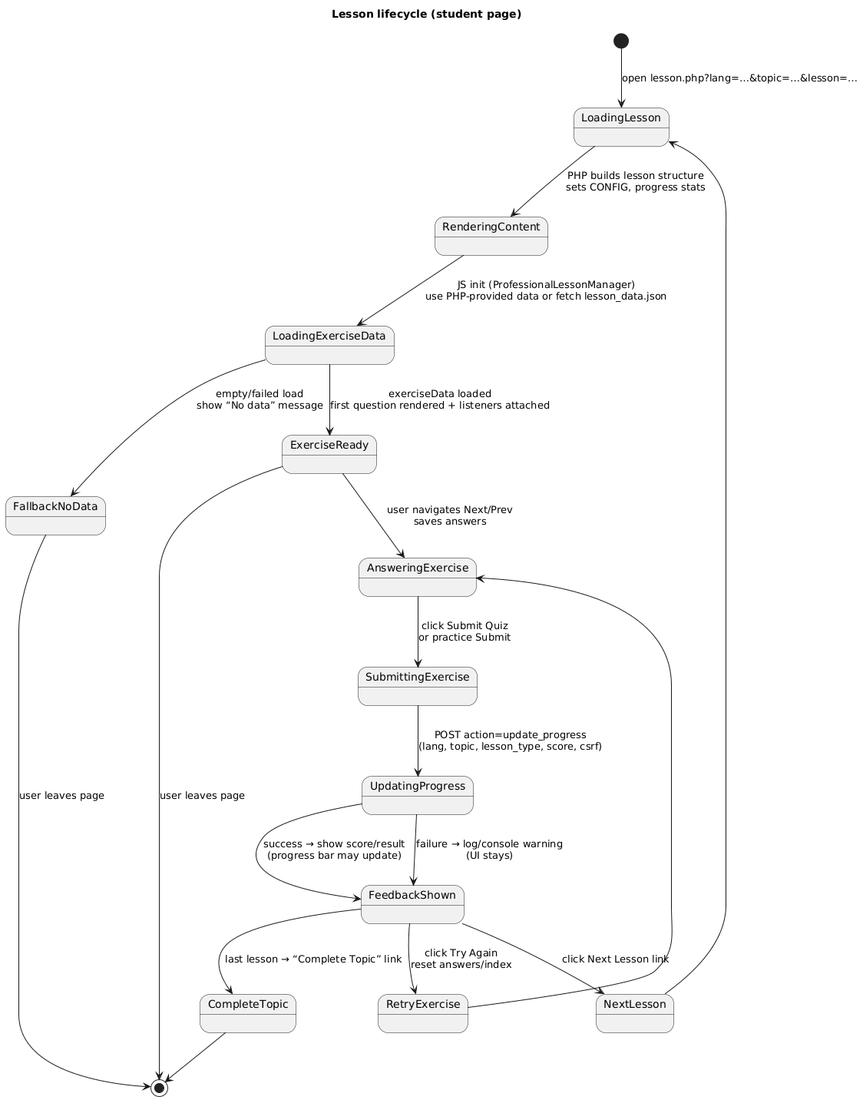
This state diagram represents the lifecycle of a lesson session from the student’s perspective. It illustrates how the lesson transitions from loading and content rendering to exercise interaction, submission, and progress updating based on user actions and system events. The diagram also includes a fallback state to handle cases where exercise data fails to load, ensuring the lesson flow terminates gracefully when the user leaves the page or completes the topic.
- Data Design (ER Schema Diagram)
This ER schema diagram shows the main database structure of the AI-powered language learning platform. It illustrates how users select a language, create documents, receive AI-generated suggestions, and take quizzes linked to specific languages. The relationships ensured storage of user data, learning content, and quiz results to support personalized language learning and progress tracking.
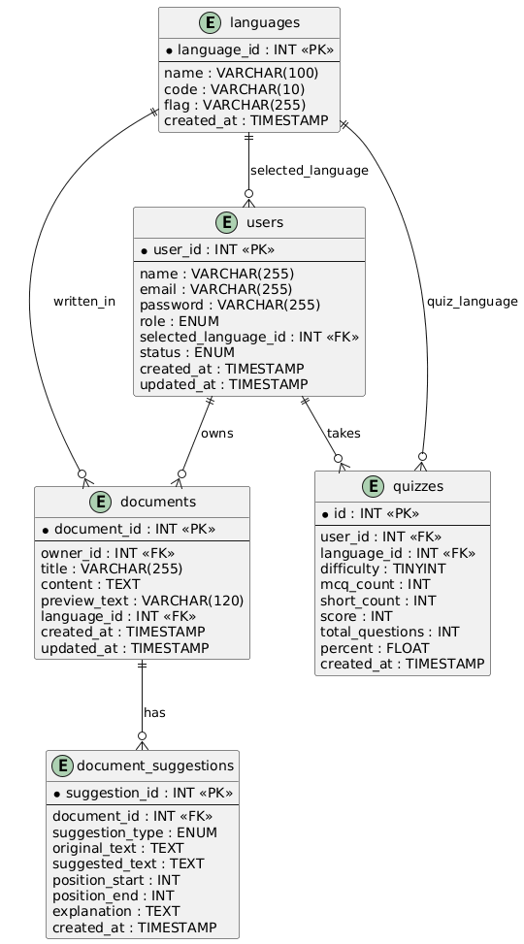
- User Interface Design
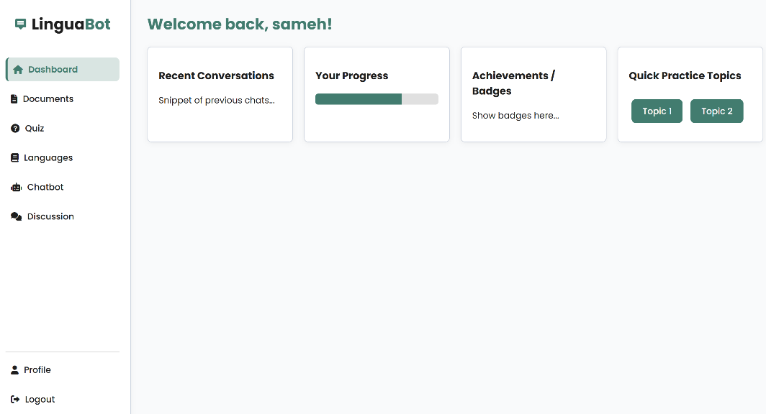
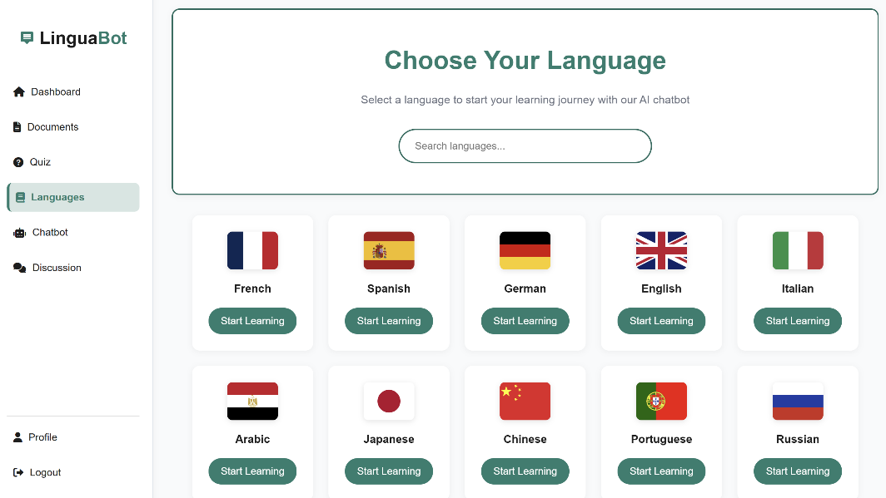
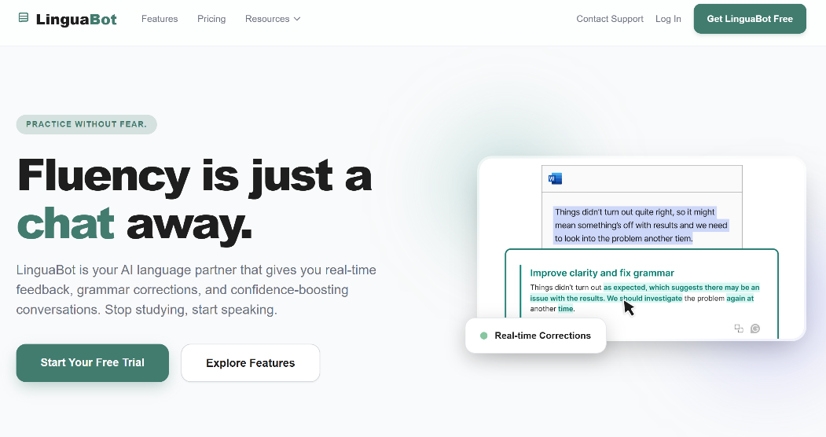
This section presents the design of the system’s user interface (UI). It highlights the layout, navigation, and visual elements that provide an intuitive and engaging experience for users.
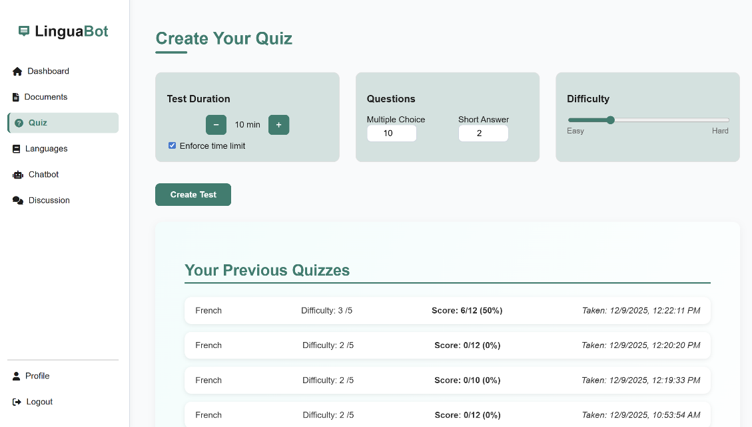
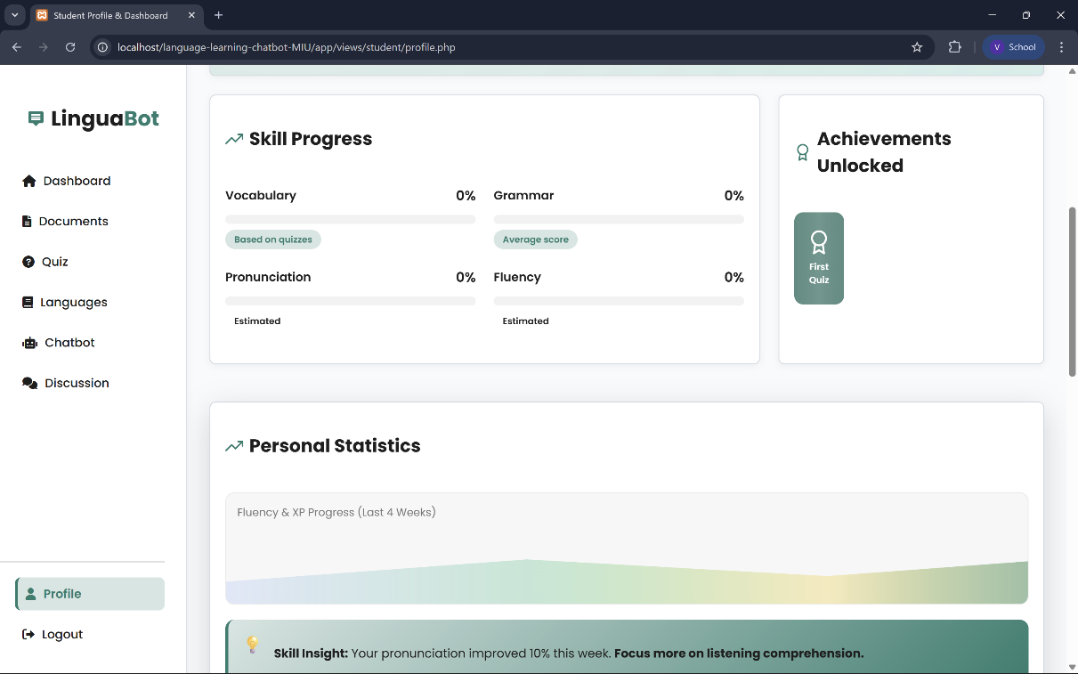

- Project Plan
Id | Task | Start Date | Number of Days | Team Member
1 | GUI | 10/10/2025 | 25 | All
2 | Login and Signup | 15/10/2025 | 14 | Veronia
3 | MVC Structure | 11/10/2025 | 2 | Mohamed
4 | CRUD | 25/10/2025 | 8 | All
5 | Error handling | 21/12/2025 | 2 | Norhan
6 | Statistics | 22/12/2025 | 1 | Norhan
7 | External Api | 12/12/2025 | 11 | all
8 | Quiz Page | 17/10/2025 | 18 | Veronia
9 | Languages | 16/10/2025 | 4 | Mohanad
10 | Topics | 20/10/2025 | 3 | Mohanad
11 | Lessons | 22/10/2025 | 3 | Mohanad
12 | Dictionary | 19/10/2025 | 1 | Mohanad
13 | Dataset Files | 15/12/2025 | 4 | Mohanad
14 | Backend Tasks | 12/12/2025 | 10 | all
15 | Testing | 15/12/2025 | 2 | Mohamed
16 | Deployment | 22/12/2022 | 1 | Mohamed
17 | Github | 1/10/2025 | 90 | All
18 | Diagrams | 18/12/2022 | 5 | All

- Task Distribution
Team Member | Module / Feature | Frontend Responsibilities | Backend Responsibilities
Norhan | Home & About Us& document& analytics for users performance | Home page UI, About Us page UI,  analytics for users UI | Backend for Home & About us& External document API integration& chatbot integration
Veronia | Quizzes System&  Contact Us& login and signup | Quiz pages UI, Login page, Signup page, Continue with Google UI, contact us page Ui | User authentication (login & signup), Google OAuth integration, Quiz APIs & logic
Mohamed | Documents | Documents pages UI (view, upload, list)  Chatbot Ui | Documents APIs integration, file handling ,documents crud operations
Mohanad | Languages, Lessons & Dictionary& topics | Languages pages UI, Lessons UI, Dictionary UI, topics UI | Languages, Lessons, Dictionary, topics backend
Jana | Admin Dashboard | Admin dashboard UI, user profile UI | Admin dashboard backend, manage users, Contact Us (email subscription), student profile

